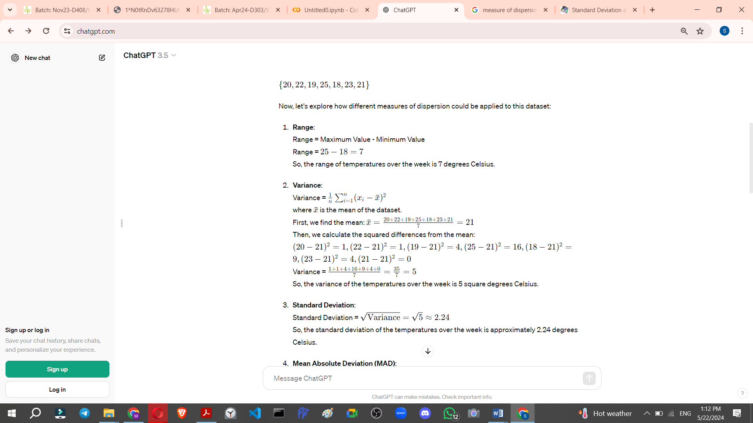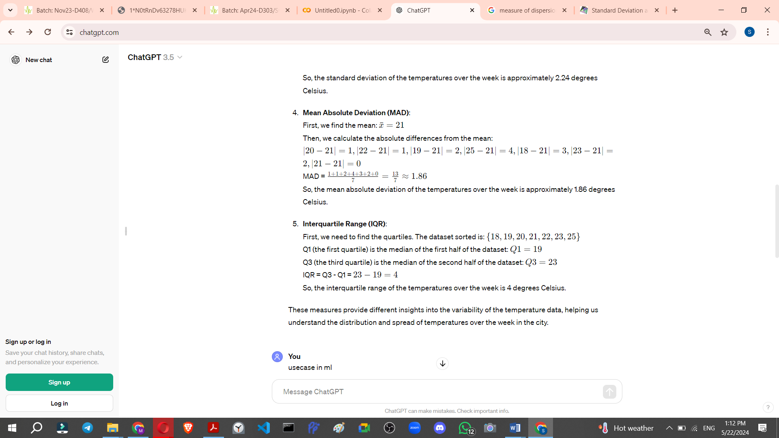

In machine learning (ML), measures of dispersion are valuable for understanding the variability of data, which can influence model selection, feature engineering, and evaluation. Let's consider a use case in ML where measures of dispersion play a crucial role:

**Use Case: Predicting House Prices**

Imagine you're working on a machine learning project to predict house prices based on various features like the size of the house, the number of bedrooms, location, etc. Here's how measures of dispersion could be applied in this scenario:

1. **Feature Selection**: Before building a predictive model, you need to select relevant features. Measures of dispersion can help identify features with high variability, which might be more informative for predicting house prices. For example, you might find that the variability in house size or the number of bedrooms is much greater compared to other features like the year built.
2. **Outlier Detection**: Outliers can significantly affect the performance of predictive models. Measures of dispersion such as standard deviation or interquartile range can be used to identify outliers in the dataset. For instance, a house with an unusually high price compared to its size or other features might be considered an outlier.
3. **Normalization and Scaling**: In many ML algorithms, feature scaling is important for ensuring that features contribute equally to the model training process. Measures of dispersion can help determine the scale of each feature. For example, if one feature has a much larger variance than others, it might dominate the learning process unless properly scaled.
4. **Evaluation Metrics**: After training the model, you need to evaluate its performance. Measures of dispersion can be useful in evaluating the consistency of predictions. For instance, you might calculate the mean absolute error (MAE) or root mean square error (RMSE) to assess how much the predicted house prices deviate from the actual prices on average.
5. **Model Interpretation**: Understanding the dispersion of predictions can provide insights into the reliability of the model. For instance, a high standard deviation of predicted prices might indicate that the model performs well on certain types of houses but struggles with others. This information can guide further model refinement or feature engineering efforts.